**TÁCH NGƯỠNG TỰ ĐỘNG DÙNG OSTSU**

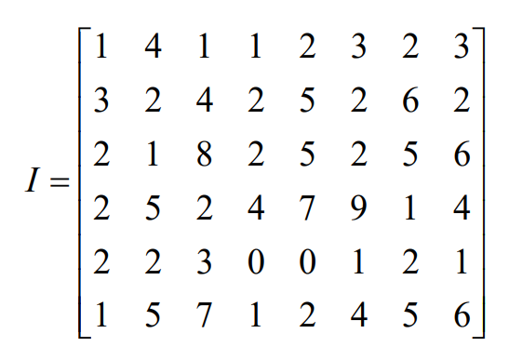

|  |  |  |  |  |
| --- | --- | --- | --- | --- |
| i | p(i) | P(i) | m(k) | Phương sai |
| 0 | 2/48 | 2/48 | 0 | 625/1472 = 0.42 |
| 1 | 9/48 | 11/48 | 9/48 | 1.58 |
| 2 | 15/48 | 13/24 | 13/16 | 2197/704 = 3.12 |
| 3 | 4/48 | 5/8 | 17/16 | 1083/320 = **3.38** |
| 4 | 5/48 | 35/48 | 71/48 | 3.23 |
| 5 | 6/48 | 41/48 | 101/48 | 2.56 |
| 6 | 3/48 | 11/12 | 119/48 | 1369/704 = 1.944 |
| 7 | 2/48 | 23/24 | 113/48 | - |
| 8 | 1/48 | 47/48 | 47/16 | 47/64 = 0.73 |
| 9 | 1/48 | 1 | **25/8** | - |